**CSE3052 - INFORMATION SECURITY MANAGEMENT**

**DIGITAL ASSIGNMENT-3**

**ALOKAM NIKHITHA**

**19BCE2555**

**Experiment-5**

**TITLE:**

Network Address Translator

**AIM:**

**To create a** Network Address Translator

**PROCEDURE:**

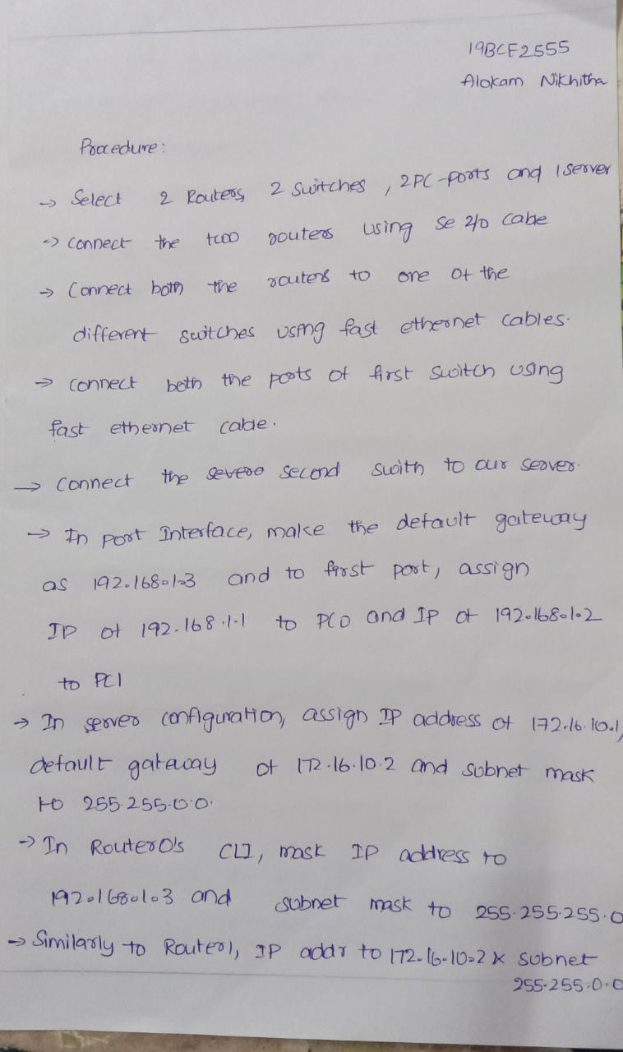

**TOPOLOGY**

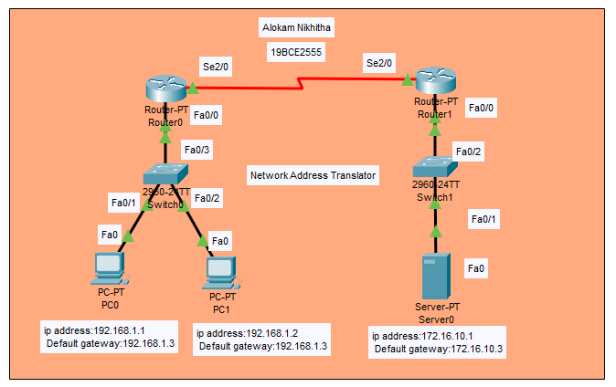

# **PC/ Computer Configuration:**

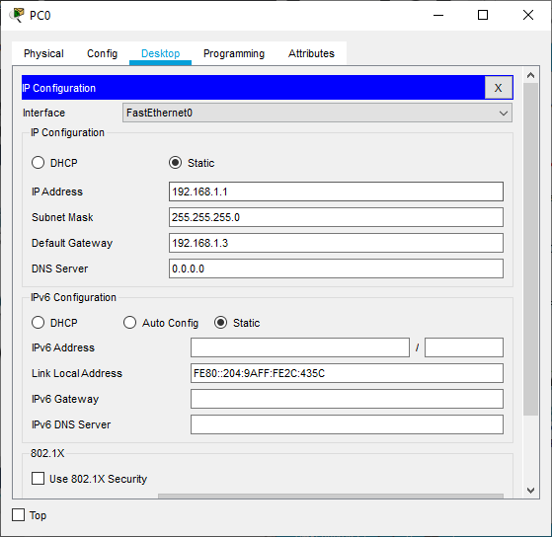

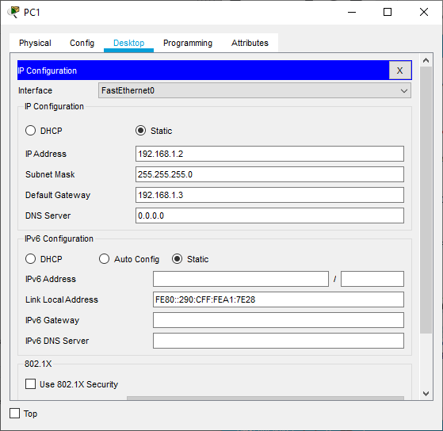

# **Server Configuration:**

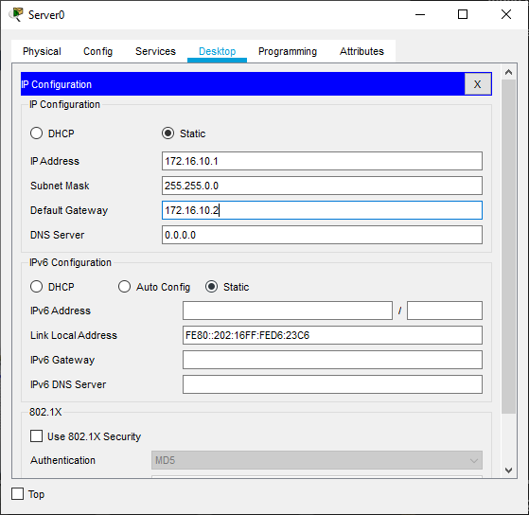

**Router Configuration:**

**Router 0**

**CLI commands**

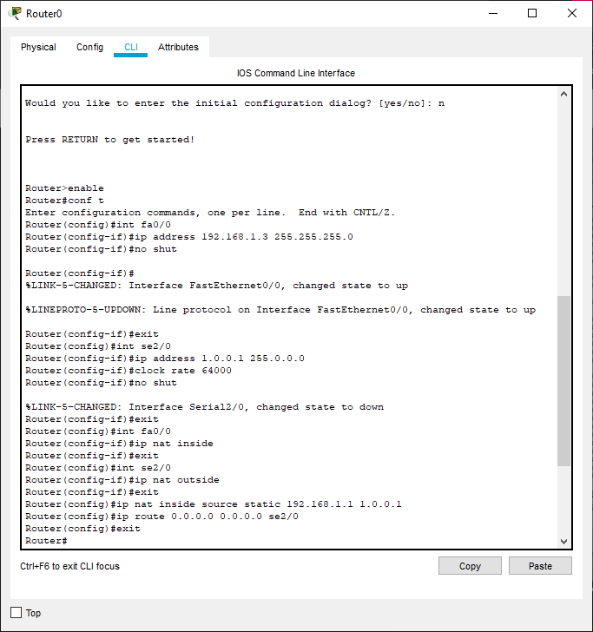

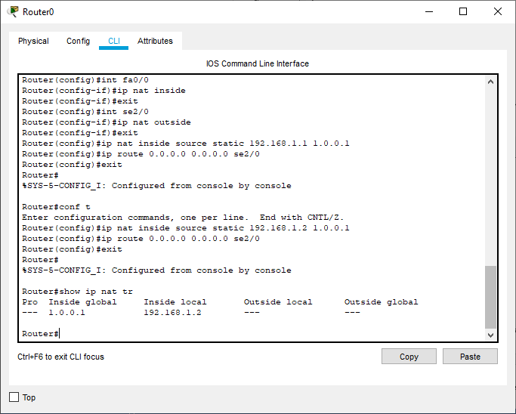

**Router 1:**

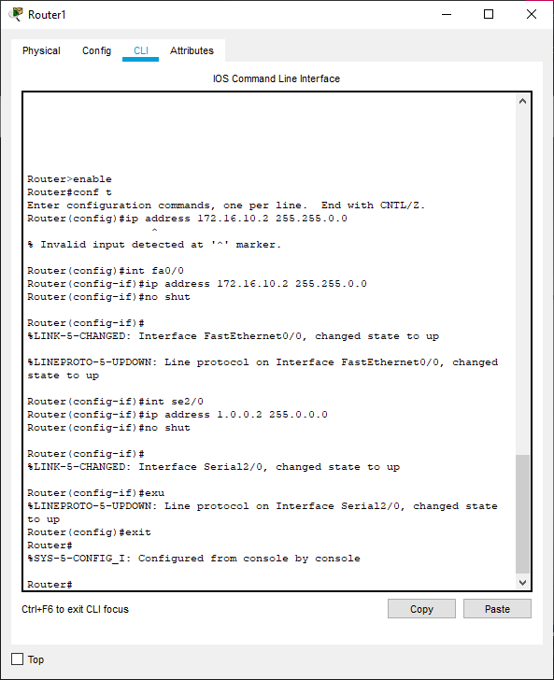

**Results**

**PC1 to Server 0**

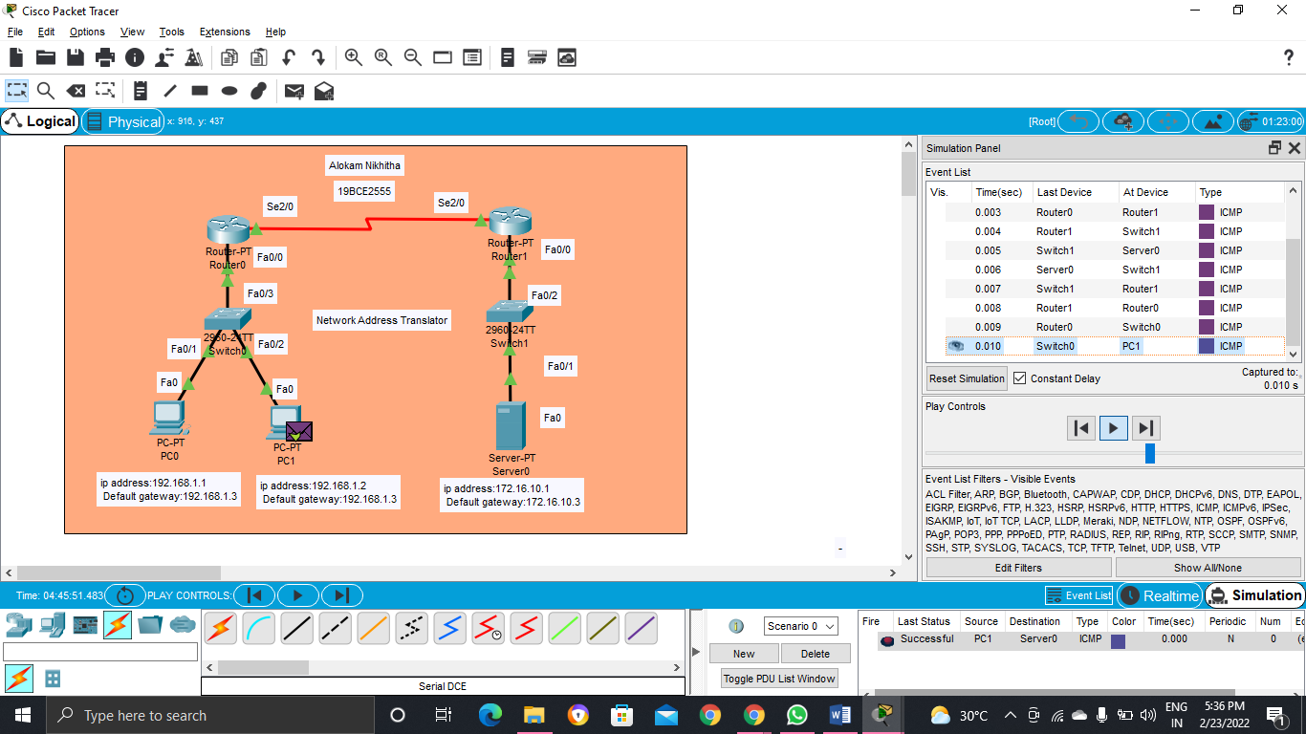

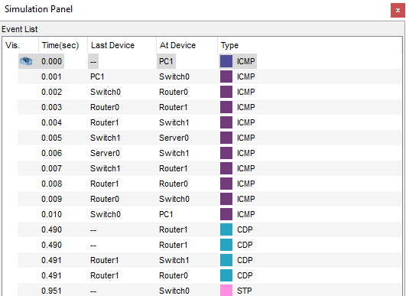

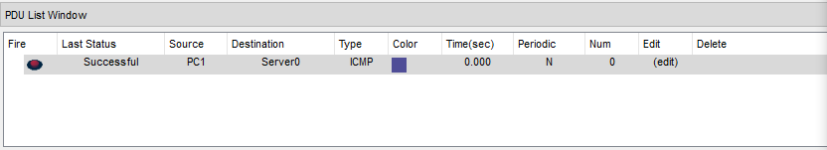

**PC0 to Server 0**

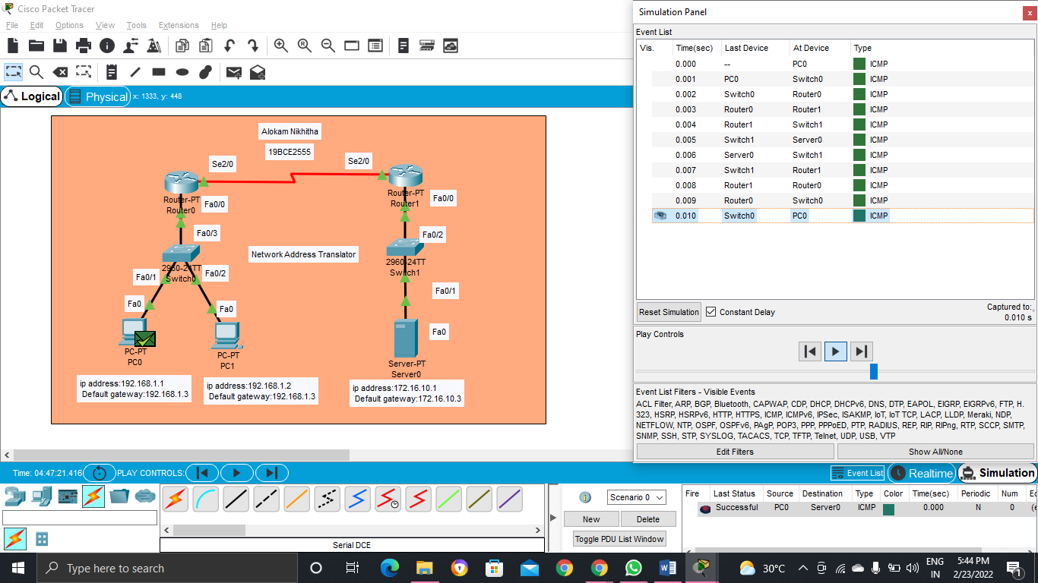

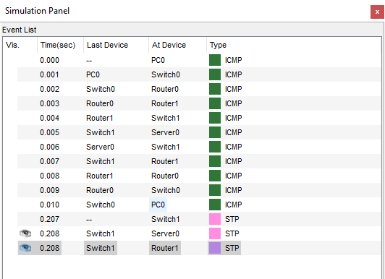

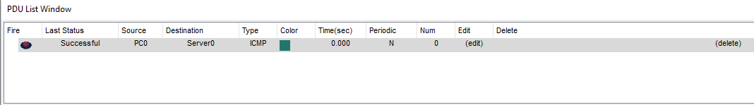

**Conclusion**

# **Here we can see that the message passed from PC0 to Server0 and PC1 to Server0 successfully with the global address instead of showing the right address.**

**Experiment-6**

**TITLE:**

Extended ACL refer the syntax with beyond 100

**AIM:**

**To create an** Extended ACL refer the syntax with beyond 100

**PROCEDURE:**

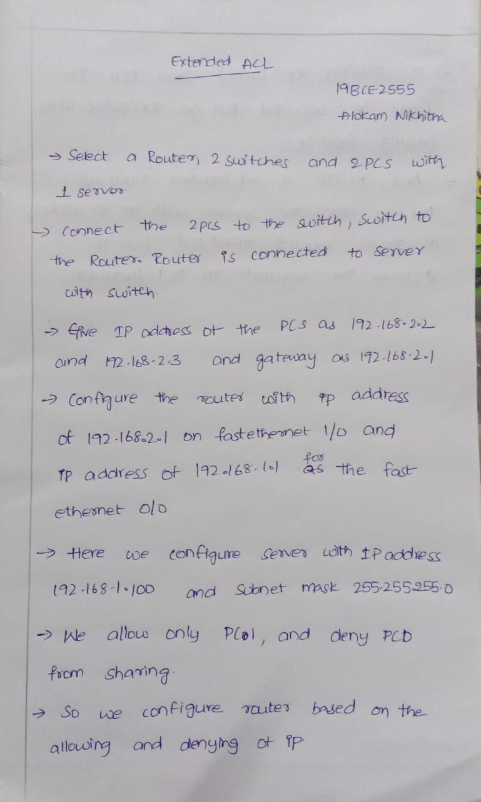

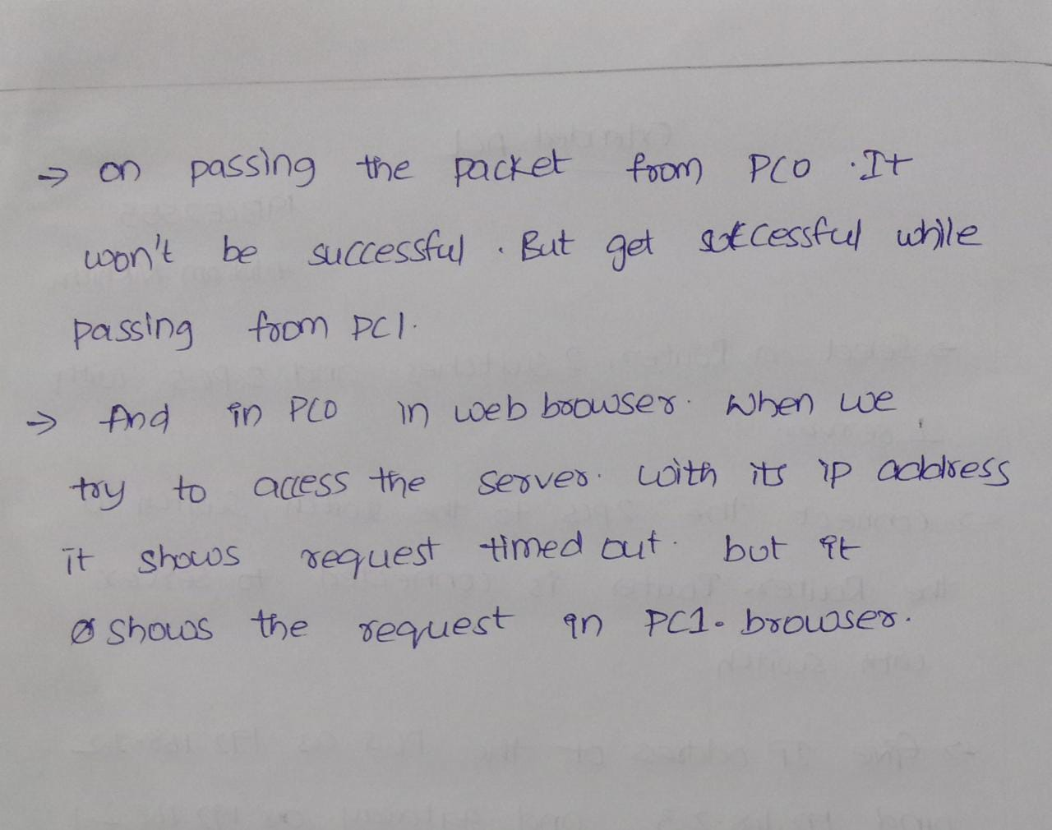

**TOPOLOGY** 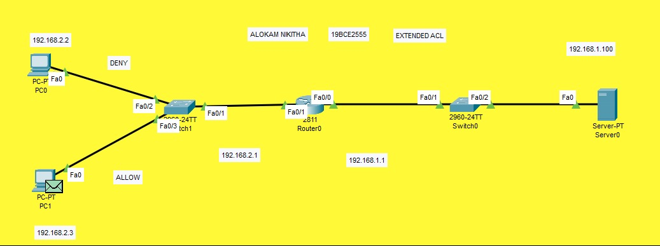

# **PC/ Computer Configuration:**

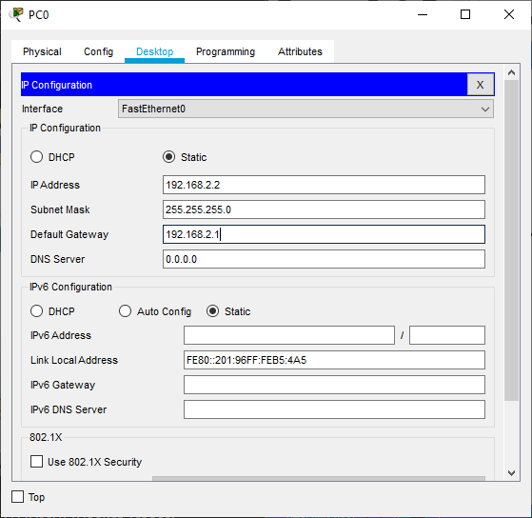

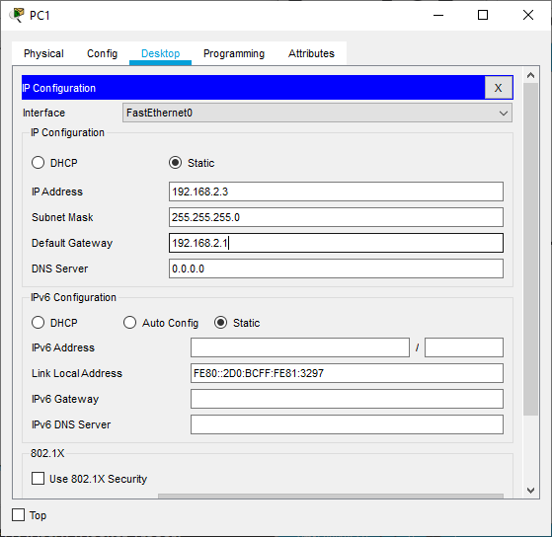

# **Server Configuration**

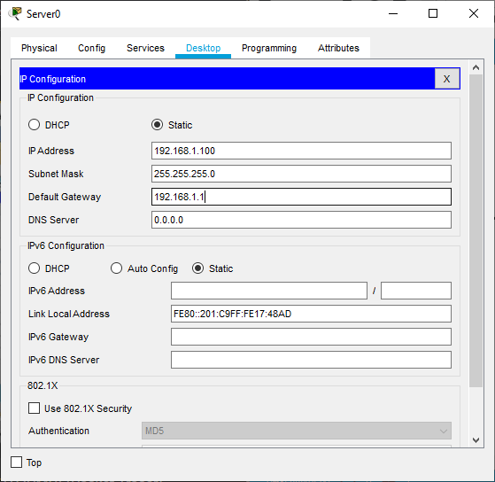

**Router Configuration:**

**Router**

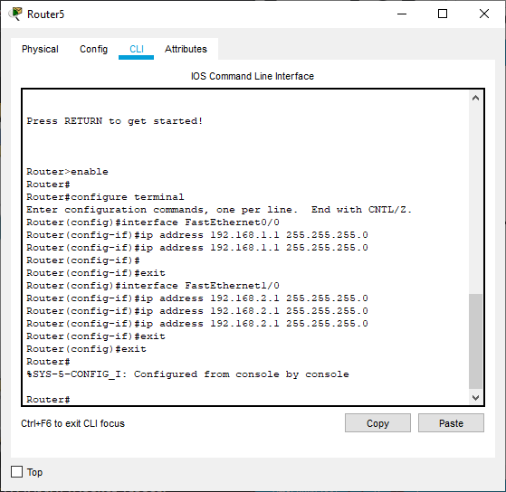

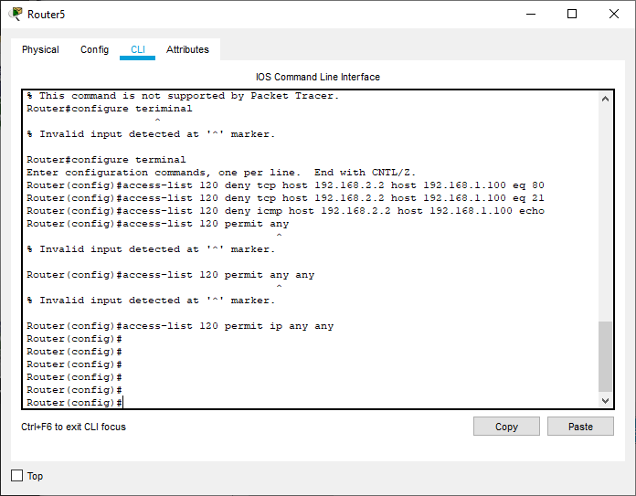

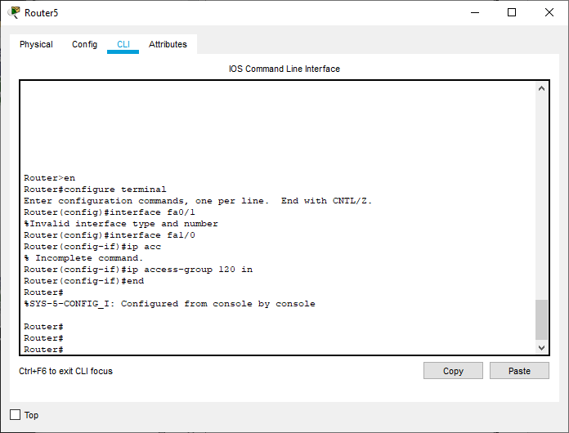

**Results**

**On passing message from PC0 TO SERVER**

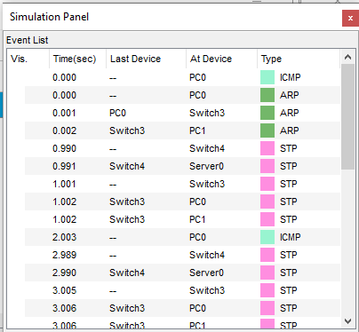

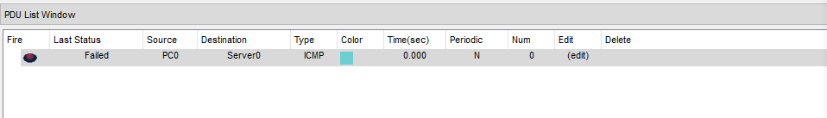

**On passing message from PC1 to Server**

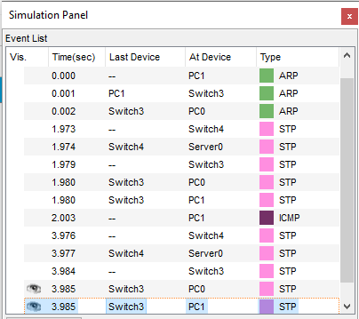

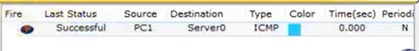

**PC0 Web browser**

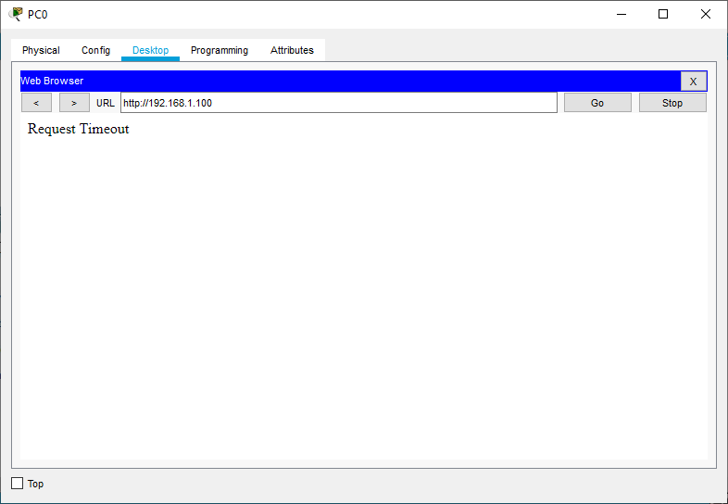

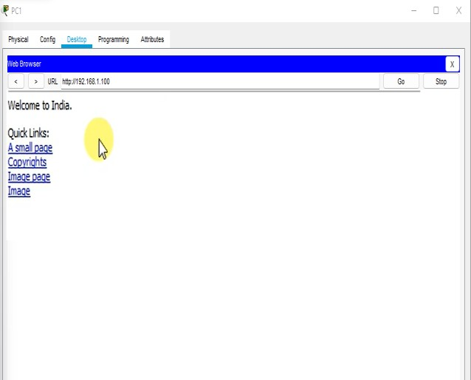**PC1 Web browser**

**PC0 Command Prompt**

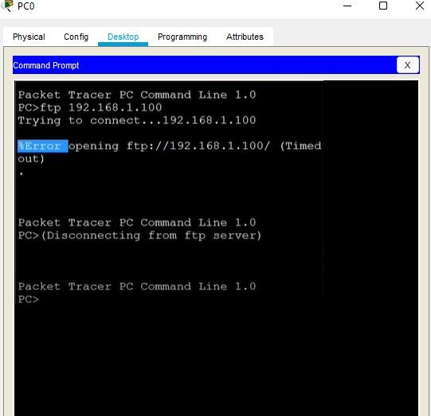

**PC1 Command Prompt**

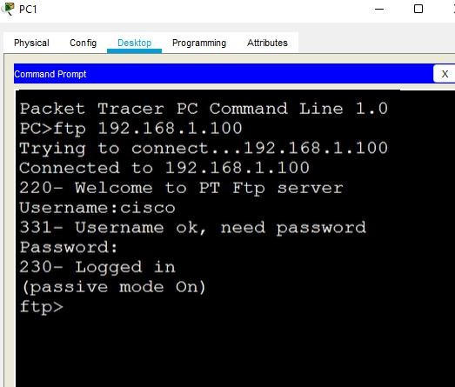

**Conclusion**

**Here we can see that we have permitted PC1 and denied PC0 . The message passed from PC0 to server is failed and PC1 to server is successful and we can see that the PC0 web browser shows timeout whereas PC1 web browser shows the request. We have allowed icmp and http on PC0.**